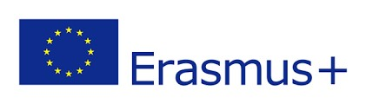
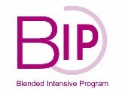
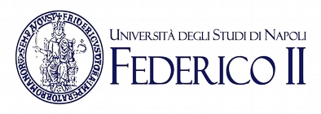
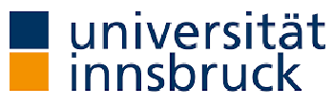
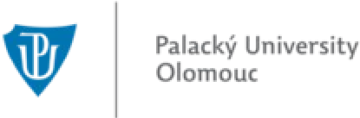
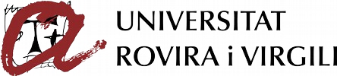
Four Aurora Alliance universities located in four
distinct geographical parts of Europe with one
common interest:

exploring and learning about the linguistic
diversity by providing a forum for plurilingualism-
inspired pedagogical approaches to come forward.
Are you a Bachelor, Master or PhD student in the
fields of Education, Humanities or Social Sciences?
This unique opportunity suits you!
online seminars
3
th, 25th and 26th
24
May 2023
in-presence
1
seminar @UNINA
18
th to 22nd
September 2023
Travels costs financially
supported by Erasmus+
Linguistic diversity,
intercultural competences
& European identity
For info UniNA: aurora.f2@unina.it; UIBK: ulrike.jessner@uibk.ac.at; UPOL ;
URV:markus.obrink@upol.cz lidia.gallego@urv.cat
€
Program of the initiative
The course will focus on testing and exchanging the best practices of the resourcefocused ideas and approaches in relation to plurilingual teaching and learning agenda in higher educational settings with the aim of fostering the development a European cultural identity based on the plurality of cultures. In doing so, we put forward a view of language plurality and linguistic diversity as assets for universities, and for their staff, faculty members, students, and society.
Learn more and apply (with a short motivation and a structured description of your language skills) at: markus.obrink@upol.cz
Virtual component
24 May 2023, please enter the time CET

From multilingualism to plurilingualism (theories and applications)
Ulrike Jessner-Schmid – Innsbruck University, Austria
In this seminar the concepts of multi- and plurilingualism will be addressed with a focus on individual, social and educational dimensions of the phenomena that have been discussed in interdisciplinary approaches stemming from several fields such psychology, sociology, ethnology, (applied) linguistics and education.
25 May 2023, 9:00-11:15 (including breaks)

Intercultural competence
Markus Öbrink – Palacký University, Olomouc, the Czech Republic
With the aim of helping the participants to learn how to work effectively in an intercultural environment and how to use diversity as a tool to improve the output of their work, the concept of Intercultural Communication will be discussed from several different viewpoints, based on the three components: attitudes, skills and knowledge.
26 May 2023, please enter the time CET

Linguistic diversity and European Identity
Alessandro Arienzo and Lídia Gallego-Balsà– Federico II University, Italy and Rovira i Virgili University, Spain
This seminar will explore how the acquisition of European identity is based on the development of plurilingual competence so Europeans can interact with members of other states. Also, the participants will reflect upon their own linguistic diversity and the value they ascribe to it.
In-presence activity
18-22 September 2023
Multidimensional reflections on plurilingualism as European reality
Alessandro Arienzo, Lídia Gallego, Ulrike Jessner-Schmid & Markus Öbrink The aim of the seminar will be on linking the content of the three online seminars in discussion rounds and presentations held by the students. The students will work both individually and in groups. English will be the main lingua franca of communication but other languages will also play a role in consonance with the plurilingual and intercultural nature of the programme.

