Registration to courses / Course enrollment

STAG – Study Agenda at Palacký University
- STAG is an application for study affairs, students, academic and administrative staff
- Portal STAG is a web place where you get all necessary information about your study, students, courses, lecturers, schedule of courses, Moodle, PU canteen…
- Portal STAG has a public and nonpublic part. Nonpublic part requires login
- If you want to enrol in a course, to find more details about a course or, for example, to order your food in UP canteen, you have to login to Portal (nonpublic part of Portal)
- To access the STAG you will need your username and your password

Portal UP- portal.upol.cz
Portal works as guidepost for different parts of Palacký Unviersity information system. The most important part for you is above mentioned STAG.
Below you can see how it looks like after you login into the system.
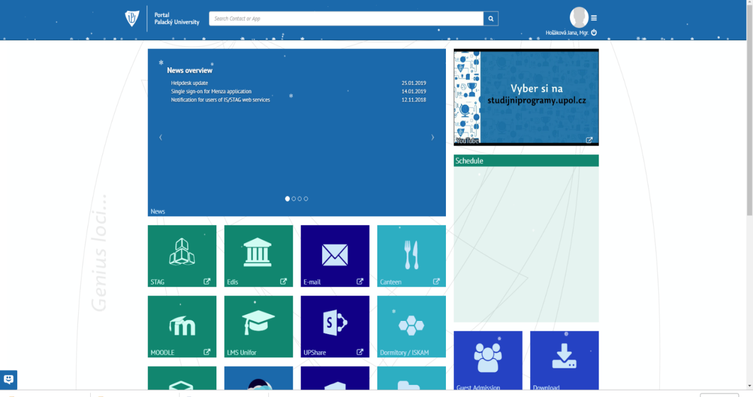
click on STAG

After you click on it, you shoudl see this:
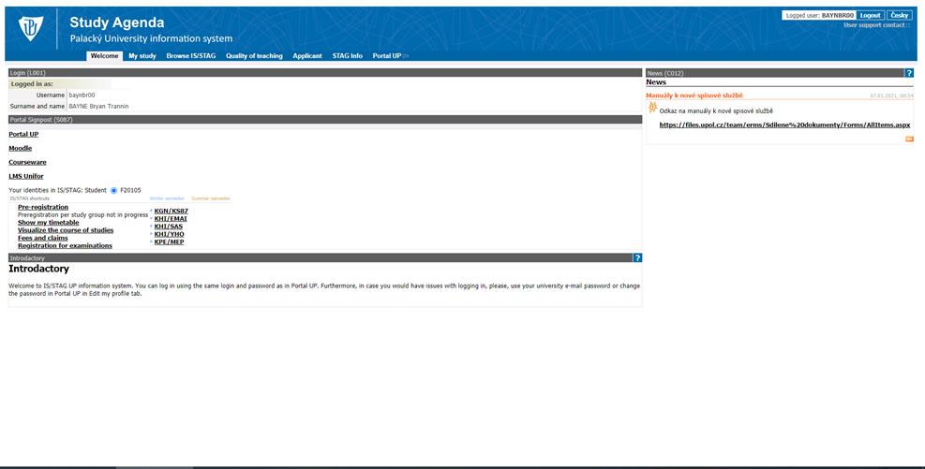

You can switch to English when you click on English in right upper corner. NOTE: Yes, most of the things will change to English, but some parts of the system will still remain in Czech.
Now, you need to go to My Study – Pre-registration
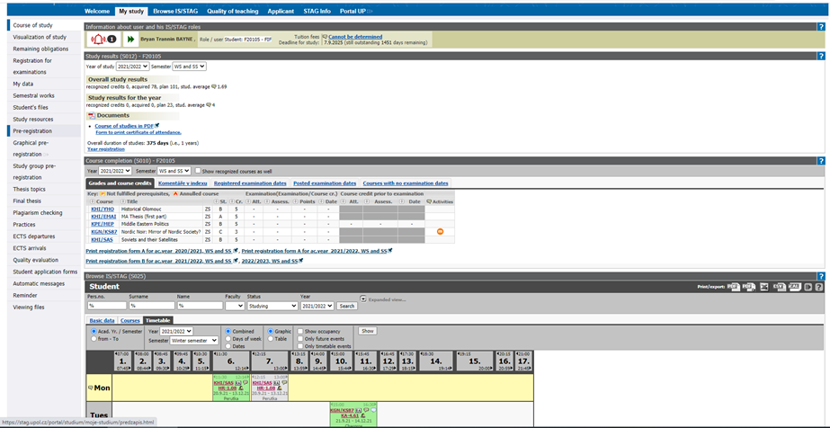
Click on Pre-registration

On the left you can see different parts of your My Study section of STAG. During your studies you will need the Pre-registration and ECTS Departures (for your 2nd and 3rd, and potentially 4th semester – there is manual specifically for this).

Pre-registration
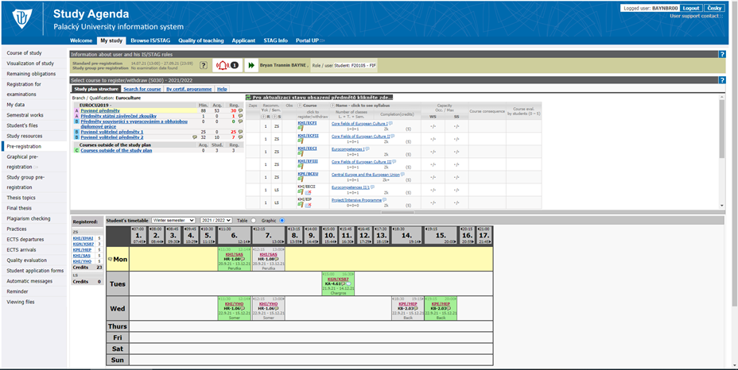
In Palacký University system all the courses are divided into three categories (A, B, C):
- A Povinné předměty – Mandatory courses: during the course of your studies you must pass all these courses
- A Předměty státní závěrečné zkoušky – Courses of the Final state exam: you will enroll to those in connection to your Final state exam in the 4th semester
- B Předměty související s vypracováním a obhajobou diplomové práce – Courses related to the writing and defense of the thesis: you will enroll to those in 3rd and 4th semesters. You can find here MA thesis first part (3rd semester, Thesis Writing Seminar and MA thesis). PLEASE NOTE THAT YOU MUST REGISTER TO THOSE COURSES REGARDLESS WHERE YOU ARE DURING THOSE SEMESTERS!!!
- B Povinné předměty 1 – Optional Courses 1: you can find Optional courses offered as a part of the Euroculture study plan here. Of course you can choose Optinal course from any department at the Faculty of Arts, but those might appear in C category (see below).
- B Povinné předměty B – Optional Courses 2: same as Optional courses 1
- C Předměty mimo studijní plán – Courses outside of the study plan: courses that are not part of the initial Euroculture study plan will show up here. That is not a problem, it is just how our system divides the courses. If it is a course that should be a part of B category, we will count it as such. And if you will attend some language courses, those will appear here as well, and will remain as C category courses here. If any course shows up here, it will still count into the overal ECTS credits you need to receive for the semester. Also, if you attend any additional courses at your 2nd unviersity (mostly language courses), those will appear here too.

To register/enroll for the course, you need to click on the abbreviation starting KHI/xxx (e.g. KHI/ECFI, KHI/ECFII and so on). When you do so, small window will open as showed below. You need to tick both option (SE and LE) and then save it („Uložit změny“) at the bottom of the window. You need to tick both because in Olomouc classes are officially divided into lecture part and seminar part (that is just a technical thing).
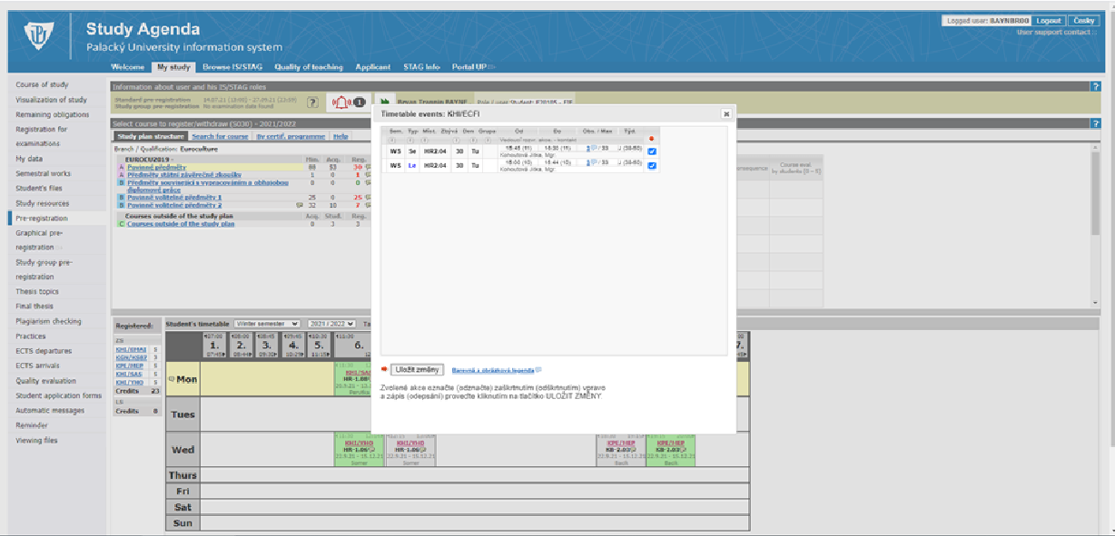
Courses you are registered to
You can see all the courses abbreviation you registered to next to the timetable. Overview of your timetable is generated automatically.

After you register to all courses required for the semester, you can download Palacký Unviersity´s app – Uplikace. There you will see all your classes for each day, it also includes map of the university etc. It is quite handy. You can find it for Android and Apple.

Here you can find explanation to some of the symbols you might seen in STAG in Pre-registration. Please note that some of those might to apply to your specific case.
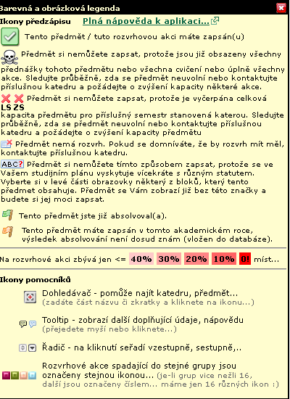
You have already passed this course.
You cannot register in this course, because you have it multiple times in your study plan.
This course has no timetable.If necessary, please contact the teacher.
The capacity of this course is full, but it is still possible to ask the teacher for the registration/to increase the capacity.
This course is not avilable because the capacity is full.
You are registered in this course

